SIOP PODC ALL-1 Protocol

A SIOP PODC Level 1 protocol and guideline for the treatment of
Acute Lymphoblastic Leukaemia in children

Adapted for Papua New Guinea

A/Professor MICHAEL SULLIVAN FRACP PhD
Head Solid Tumour and Neuro-Oncology Programs
Children’s Cancer Centre
Royal Children’s Hospital, Melbourne, Australia

Dr Gwenda Anga
Paediatrician
Department of Paediatrics
Port Morsby

May 2014

TREATMENT SCHEMA PNG ALL-1 PROTOCOL
CLINICAL ASSESSMENT
&
DIAGNOSIS

PREPHASE
Day -7 to D-1 (7 DAYS)
&
SUPPORTIVE CARE (optional)
(7 DAYS)

INDUCTION
Day 1-36 (5 weeks)

CONSOLIDATION &
CNS PROPHYLAXIS
Day 1-36 (5 weeks)

MAINTENANCE
Day 1-84 PER CYCLE X 9 CYCLES
(108 weeks)

PROTOCOL AND GUIDELINE SUMMARY

INITIAL DIAGNOSTIC INVESTIGATIONS
DISEASE DIAGNOSIS AND ASSESSEMNT
- FBC, differential count and blood film, and ESR
- Coagulation
- Electrolytes and liver function tests, including phosphate and calcium, Creatinine, Urea and Urate
- CXR – do before any invasive procedures to exclude a mediastinal mass.
- US Scan of abdomen (optional if available)
- Bone marrow aspirate and trephine biopsy
- LP for CSF cytology (specifically request laboratory to do cytospin and microscopy for blasts in csf)
- Cytogenetics – (optional, only if available)
- Flow cytometry – (optional, only if available)

PATIENT ASSESSMENT
- Growth, and nutritional status – weight for age
- Weight and surface area – (see table Appendix for surface area by weight)
- Dental health
- Skin sores, impetigo
- Cardiorespiratory status, previous chronic suppurative lung disease, rheumatic carditis
- Iron and vitamin deficiency
- TB, HIV, hepatitis A and B, malaria, parasites and other relevant tropical infections
- Family, home, financial and school history

LEUKAEMIA SPECIFIC ASSESSMENT
- Sepsis and septic shock
- Pancytopenia, severe acute anaemia
- Hyperleucocytosis
- Tumour lysis syndrome
- Superior venocaval syndrome
- Central nervous system disease
- Testicular disease

SUPPORTIVE CARE AT DIAGNOSIS
- Transfuse red cells and platelets as needed – at diagnosis maintain Hb > 80gm/L and platelets > 50
- Tumour lysis therapy
- hyperhydration (N/Saline or Dextrose/Saline) 3L/m²/day
- Allopurinol 100mg/m²/dose three times daily
- Antibiotic treatment and prophylaxis
- If febrile or septic treat as for febrile neutropenia protocol with Ceftriaxone 50kg/kg dose and Gentamicin (adjust gentamicin dose for renal function)
- Cotrimoxazole (sulphamethoxazole/trimethoprim at 5 mg/kg/day of trimethoprim) in two doses daily. Give daily from Day -7 to Day 0, then continue as prophylaxis against pneumocystis at trimethoprim 5mg/kg/day in two doses, on three days per week
- Fluconazole 6mg/kg/day (max 400 mg/day) during pre-phase, induction and consolidation
- Isoniazid 10mg/kg/day po (max 300 mg/day) prophylaxis throughout therapy for those at risk of TB
- Antihelminthic therapy – albendazole 20 mg/kg once at diagnosis and repeat in 2 weeks
- Consider metronidazole for dental/gingival disease and amoebic infection
- Nutritional support
- Iron and vitamin replacement at diagnosis (do not use folate containing multivitamins once on therapy)
- Rheumatic carditis, continue or commence monthly benzyl penicillin

TREATMENT ROADMAP: PODC PNG ALL 1.0 Protocol and Guideline

1. STEROID PRE-PHASE DAY -7 TO DAY -1

The pre-induction phase is designed to stabilise the patient, confirm the diagnosis, treat inter-current infections and make conditions optimal for starting induction chemotherapy.

Day -7- 0 (1 week) | -7 | -6 | -5 | -4 | -3 | -2 | -1
Hyperhydration 3L/m²/24 and Allopurinol 100mg/m²/ tds | xxxx | xxxx | xxxx | xxxx | xxxx
Prednisone 10 mg/m²/day po in two divided doses
Prednisone 20 mg/m²/day po in two divided doses
Prednisone 40 mg/m²/day po in two divided doses
IT Methotrexate (age related doses), intrathecal
Methotrexate 1-2 yrs, 8 mg; 2-3 years, 10 mg; >3 years 12 mg
- At Day -1, reassess patient, and review response of disease and supportive care. Consider additional 7-10 day supportive care
- Daily blood count, electrolytes, Cr and Urate
- Continue tumour lysis therapy with hyperhydration and allopurinol until total WCC < 5 and normal Cr, urea and urate

2. INDUCTION PHASE D1-36
If clinically stable proceed to induction – this is D1 of induction therapy. But if unwell and in need of continuing supportive care consider deferring the start of induction for a further 7 days to continue treat infection and to improve nutritional status.

Day 1-36 (5 weeks) | 1 | 8 | 15 | 22 | 29 | 36
Vincristine 1.5 mg/m²/dose, (2 mg max) i.v. push D1, 8, 15, 22
Asparaginase ( E coli, Leunase) 6000 U/ m²/dose, i.m. for 9 doses given 3x per week Mon, Wed, Fri, for 3 weeks
Prednisone 40 mg/m²/day p.o. in two divided doses D 1-29
IT Methotrexate (age related doses), intrathecal, D2 and 16
Methotrexate 1-2 yrs, 8 mg; 2-3 years, 10 mg; >3 years 12 mg
Bone marrow aspirate on D29 |  |  |  |  | BMA
- Blood count Day 1, 8, 15, 22, 29, 36 (weekly)
- Continue supportive care with cotrimoxazole bd, Friday, Saturday, Sunday, fluconazole daily, and isoniazid
- Bone marrow aspirate on D 29 to assess disease response and review ongoing therapy (optional).
- Remission is less than < 5% blasts; if > 10% blasts at D29 this is an induction failure - review options for ongoing therapy
- See details below for administration and side effects of Asparaginase and Intrathecal methotrexate
- If no Asparaginase available, substitute with Daunorubicin 25 mg/m²/dose on Day 1 and Day 15

3. CONSOLIDATION AND CNS PROPHYLAXIS PHASE

If clinically stable and Neutrophil count >1.0, and platelets >75, start consolidation at Day 36 of Induction, this is Day 1 of Consolidation and CNS prophylaxis. But if the blood count has not recovered, or if further supportive care is required defer the start of consolidation and CNS prophylaxis for a further 7 days.

Day 1-36 (5 Weeks) | 1 | 8 | 15 | 22 | 29 | 36
Vincristine 1.5 mg/m²/dose, (2 mg max) iv push D1, 8, 15, 22
Mercaptopurine 75 mg/m²/dose, p.o, taken at night, D1-28 | •••••••••••••••••••••••••••
IT Methotrexate (age related doses), intrathecal, D 2, 9 and 16
Age 1-2 yrs, 8 mg; 2-3 years, 10 mg; >3 years 12 mg
- Blood count Day 1, 15, 29 (monthly)
- Continue supportive care with cotrimoxazole bd, Friday, Saturday, Sunday, fluconazole daily, and isoniazid

4. MAINTENANCE PHASE
Commence maintenance therapy when Neutrophil count >1.0, and platelets >75. Maintenance is 9 cycles of 12 weeks per cycle

Day 1-84 (12 Weeks PER CYCLE) for 108 WEEKS | 1 | 8 | 15 | 22 | 29 | 36 | 43 | 50 | 57 | 64 | 71 | 77 | 84
IT Methotrexate, D 2 and 30* for the first 4 cycles, then D2 for the next 5 cycles. Age 1-2 yrs, 8 mg; 2-3 years, 10 mg; >3 years 12 mg |  |  |  |  | *
Vincristine 1.5 mg/m²/dose, (2 mg max) iv push D1, 29, 57
Prednisone 40/m²/day, p.o. in two doses
D 1-5, 29-33, 57-61
Methotrexate 20 mg/m²/dose, p.o once weekly
D 1, 8, 15, 22, 29, 36, 43, 50, 57, 64, 71, 77, 84
Mercaptopurine 50 mg/m²/dose, p.o daily, at night 2 hours after a meal | ••••••••••••••••••••••••••••••••••••••••••••••••••••••••••
- Blood count Day 1, 29, 57 (monthly) Continue supportive care with cotrimoxazole bd, Friday, Saturday, Sunday, and isoniazid

APPPENDIX 1.0: SURFACE AREA CALCULATION AND WEIGHT BASED SURFACE AREA

(Sharkey et al, British Journal of Cancer 2001 85, 23-28)
To calculate surface area:  Surface area = $\sqrt[2]{\frac{height \left(cm\right) x weight(cm)}{3600}}$ | 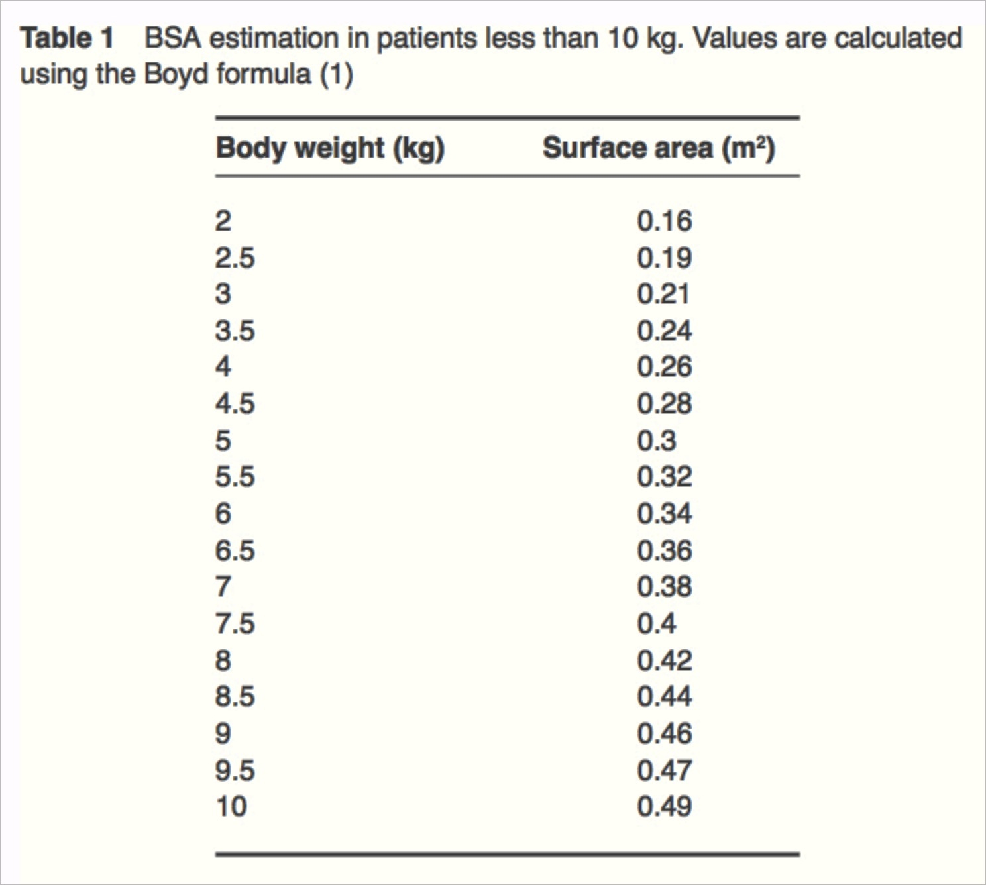
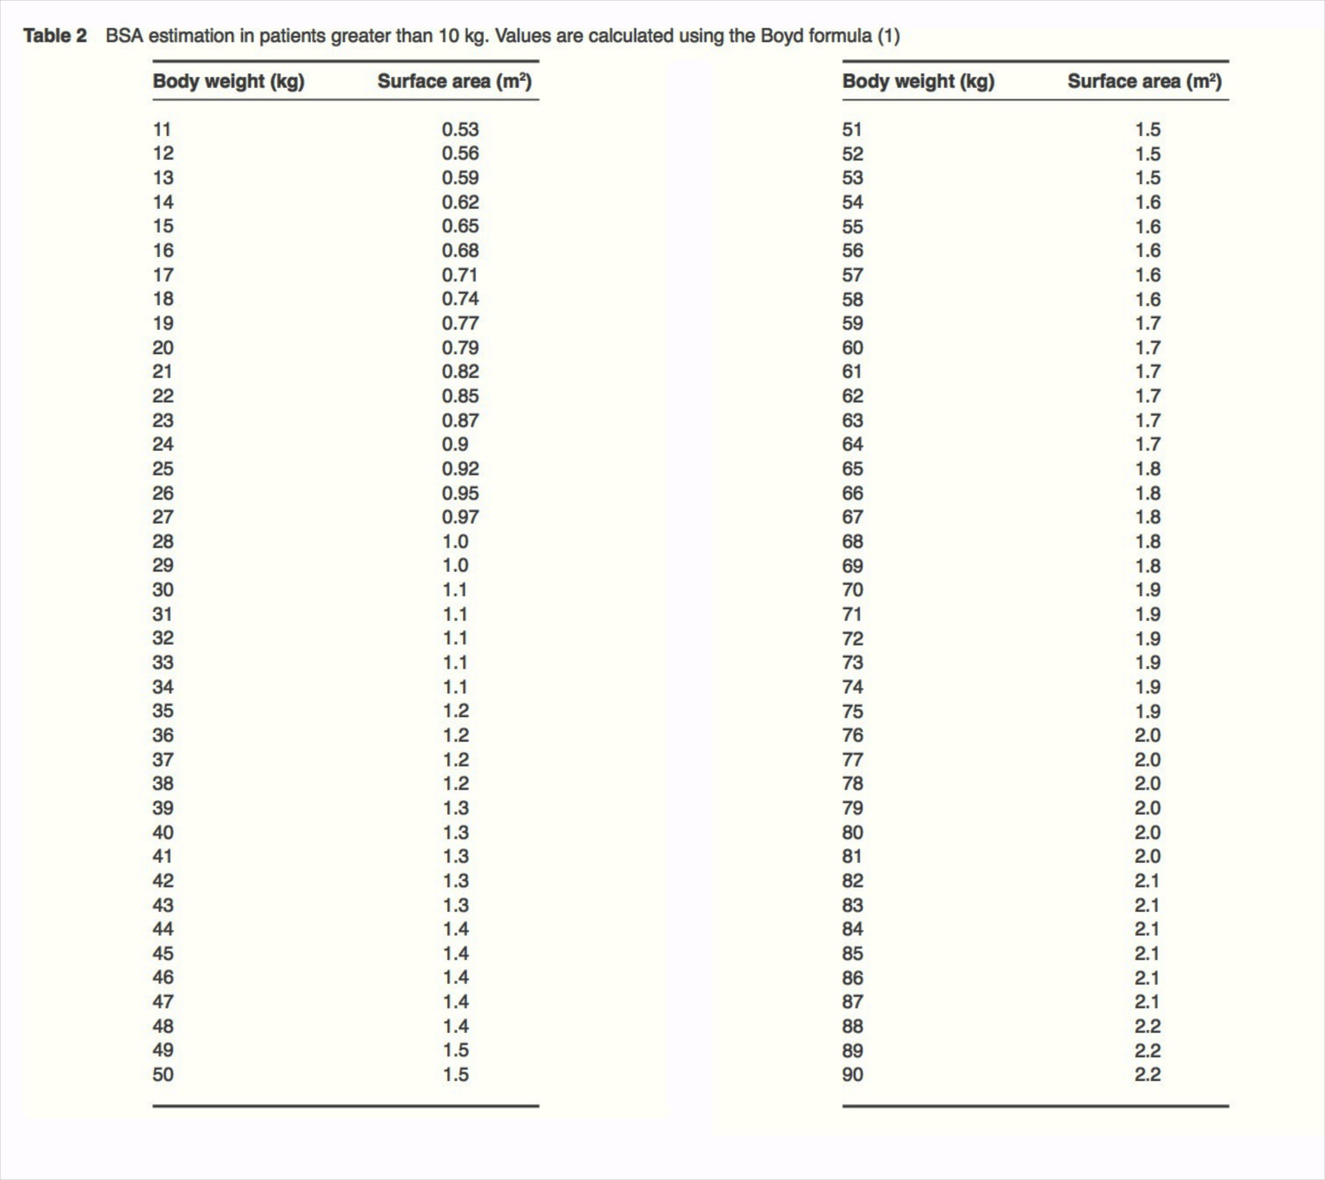

APPENDIX 2.0: WEEKLY MERCAPTOPURINE DOSING 50 mg/m²/day (350 mg/m²/week)

MERCAPTOPURINE 50mg/m²/day
Surface area | Dose per week (tabs) | daily dose
0.47 – 0.53 | 3.5 | half a tablet daily on 7 days
0.54 – 0.6 | 4 | half a tablet daily on 6 days and one tablet on day 7
0.61 – 0.67 | 4.5 | half a tablet daily on 5 days and one tablet daily on 2 days
0.68 – 0.74 | 5 | half a tablet daily on 4 days and one tablet daily on 3 days
0.75 – 0.82 | 5.5 | half a tablet daily on 3 days and one tablet daily on 4 days
0.83 – 0.89 | 6 | half a tablet daily on 2 days and one tablet daily on 5 days
0.9 – 0.96 | 6.5 | half a tablet on one day and one tablet daily on 6 days
0.97 – 1.03 | 7 | one tablet daily on 7 days
1.04 – 1.1 | 7.5 | one tablet daily on 6 days and one and a half tablets on day 7
1.11 – 1.17 | 8 | one tablet daily on 5 days and one and a half tablets daily on 2 days
1.18 – 1.24 | 8.5 | one tablet daily on 4 days and one and a half tablets daily on 3 days
1.25 – 1.32 | 9 | one tablet daily on 3 days and one and a half tablets daily on 4 days
1.33 – 1.39 | 9.5 | one tablet daily on 2 days and one and a half tablets daily on 5 days
1.4 – 1.46 | 10 | one tablet daily on one day and one and a half tablets daily on 6 days
1.47 – 1.53 | 10.5 | one and a half tablets daily on 7 days
1.54 – 1.6 | 11 | one and a half tablets daily on 6 days and two tablets on day 7
1.61 – 1.67 | 11.5 | one and a half tablets daily on 5 days and two tablets daily on 2 days
1.68 – 1.74 | 12 | one and a half tablets daily on 4 days and two tablets daily on 3 days
1.75 – 1.82 | 12.5 | one and a half tablets daily on 3 days and two tablets daily on 4 days
1.83 – 1.89 | 13 | one and a half tablets daily on 2 days and two tablets daily on 5 days
1.9 – 1.96 | 13.5 | one and a half tablets on one day and two tablets daily on 6 days
1.97 – 2.03 | 14 | two tablets daily on 7 days
2.04 – 2.1 | 14.5 | two tablets daily on 6 days and two and a half tablets daily on day 7

APPENDIX 3.0: WEEKLY METHOTREXATE DOSING 20 mg/m²/dose (20 mg/m²/week)

METHOTREXATE 20mg/m²/week
Surface area | Dose per week (mg) | Number of tablets per single weekly dose
Surface area | Dose per week (mg) | 2.5mg | 10mg
0.4 | 7.5 | 3 | -
0.41 – 0.46 | 8.75 | 3 ½ | -
0.47 – 0.53 | 10 | - | 1
0.54 – 0.59 | 11.25 | ½ | 1
0.6 – 0.65 | 12.5 | 1 | 1
0.66 – 0.71 | 13.75 | 1 ½ | 1
0.72 – 0.78 | 15 | 2 | 1
0.79 – 0.84 | 16.25 | 2 ½ | 1
0.85 – 0.9 | 17.5 | 3 | 1
0.91 – 0.96 | 18.75 | 3 ½ | 1
0.97 – 1.03 | 20 | - | 2
1.04 – 1.09 | 21.25 | ½ | 2
1.1 – 1.15 | 22.5 | 1 | 2
1.16 – 1.21 | 23.75 | 1 ½ | 2
1.22 – 1.28 | 25 | 2 | 2
1.29 – 1.34 | 26.25 | 2 ½ | 2
1.35 – 1.4 | 27.5 | 3 | 2
1.41 – 1.46 | 28.75 | 3 ½ | 2
1.47 – 1.53 | 30 | - | 3
1.54 – 1.59 | 31.25 | ½ | 3
1.6 – 1.65 | 32.5 | 1 | 3
1.66 – 1.71 | 33.75 | 1 ½ | 3
1.72 – 1.78 | 35 | 2 | 3
1.79 – 1.84 | 36.25 | 2 ½ | 3
1.85 – 1.9 | 37.5 | 3 | 3
1.91 – 1.96 | 38.75 | 3 ½ | 3
1.97 – 2.03 | 40 | - | 4
2.04 – 2.09 | 41.25 | ½ | 4
2.1 | 42.5 | 1 | 4

APPENDIX 4.0: CYTOTOXIC MEDICINES (WHO FORMULARY)
(WHO MODEL FORMULARY FOR CHILDREN 2010: (www.who.int/selection_medicines/list/WMFc_2010.pdf)

NOTE. WHO advises that while cytotoxic medicines are essential for the treatment of malignancy in children, adequate resources and specialist supervision are a prerequisite for the introduction of this class of drugs. Specific expertise, diagnostic precision, individualization of dosage and special equipment are required for their proper use. There are many differences in the spectrum and management of childhood cancers, compared to adult cancers, and the treatment of malignancy in children with drugs, radiotherapy and surgery is complex and should only be undertaken by specialists in this field. For this reason, the following information is provided merely as a guide.
Chemotherapy may be curative or used to alleviate symptoms or prolong life (palliative). When the condition can no longer be managed with cytotoxic therapy, alternative palliative treatment should be considered.
For some tumours, single-drug chemotherapy may be adequate, but for most malignancies, a combination of drugs provides the best response; specialist literature should be consulted. Cytotoxic drugs are often combined with other classes of drugs in the treatment of malignant conditions. Such drugs include hormone agonists and antagonists, corticosteroids and immunosuppressant drugs. Combinations are, however, more toxic than single drugs.
Cytotoxic medications should be used with great care and close monitoring. Specific doses and details of contraindications, precautions and adverse effects for the individual cytotoxic drugs have been omitted in the following section since treatment should be undertaken by specialists using approved regimens; specialist literature should be consulted for further information.
Adverse effects: Cytotoxic drugs have a considerable potential to damage normal tissue. Specific adverse effects apply, but a number are common to all cytotoxics, such as bone marrow and immunological suppression. The concomitant use of immunosuppressive drugs will enhance susceptibility to infections. Fever associated with neutropenia requires immediate treatment with antibiotics.
Nausea and vomiting: following administration of cytotoxic drugs and abdominal radiotherapy are often distressing and may compromise further treatment. Symptoms may be acute (occurring within 24 hours of treatment), delayed (first occurring more than 24 hours after treatment) or anticipatory (occurring before subsequent doses).
Hyperuricaemia may complicate treatment of conditions such as non-Hodgkin lymphomas and leukaemia. Renal damage may result from the formation of uric acid crystals. Patients should be adequately hydrated, and hyperuricaemia may be managed with allopurinol.
Alopecia: is common during treatment with cytotoxic drugs. There is no drug treatment, but the condition often reverses spontaneously once treatment has stopped.
Oral mucositis: is common during cancer chemotherapy, particularly with fluorouracil, methotrexate and anthracyclines. Prevention of a sore mouth is important, because once it has developed treatment is much less effective. Brushing teeth with a soft brush two to three times daily and rinsing the mouth frequently are probably the most effective preventative measures. Treatment involves regular use of saline mouthwashes. Generally mucositis is self-limiting, but it can be a focus for blood-borne infection in the absence of good oral hygiene. Any pain caused by mucositis should be dealt with effectively.

1.0 ALLOPURINOL
ATC code: M04AA01 Tablet: 100 mg to 300 mg
Indications: Prophylaxis of hyperuricaemia associated with cancer chemotherapy.
Dose: Prophylaxis of hyperuricaemia associated with cancer chemotherapy beginning 1–2 days before chemotherapy. Oral: Child 1 month–12 years 10–20 mg/kg daily (maximum 400 mg) preferably after food. Doses > 300 mg should be administered as divided doses.
Contraindications: Acute gout; previous allopurinol-induced rash.
Precautions: ensure adequate fluid intake; renal impairment; hepatic impairment; withdraw treatment if rash occurs.
For hyperuricaemia associated with cancer therapy, allopurinol should be started before cancer therapy.
RASH: Risk of skin rash may be increased in patients receiving amoxicillin or ampicillin. The risk of hypersensitivity may also be increased in patients receiving thiazides or ACE inhibitors. If a rash occurs, treatment should be stopped; treatment may be reintroduced if the rash is mild but discontinue immediately if it recurs. Renal impairment: Mild: no dosage reduction necessary. Moderate: 50% of usual dose. Severe: 30% of usual dose. Hepatic impairment: Reduce dose and monitor liver function.

Adverse effects:
Common: Rash (see Precautions above), gastrointestinal intolerance.
Uncommon: Hypertension, alopecia, hepatotoxicity, paraesthesia, neuropathy, gynaecomastia.
Rare: Hypersensitivity reactions including fever, lymphadenopathy, arthralgia, eosinophilia, erythema multiforme (Stevens-Johnson syndrome) or toxic epidermal necrolysis, vasculitis, hepatitis, renal impairment, malaise, headache, vertigo, drowsiness, visual and taste disturbance.
Very rare: Seizures, blood disorders (including leukopenia, thrombocytopenia, haemolytic anaemia and aplastic anaemia).

Interactions with other medicines (* indicates severe): Amoxicillin: increased risk of rash and hypersensitivity.
Ampicillin: increased risk of rash and hypersensitivity.* Azathioprine: effects of azathioprine enhanced and toxicity increased; reduce dose of azathioprine. Ciclosporin: plasma ciclosporin concentration possibly increased (risk of nephrotoxicity). * Cyclophosphamide: increased risk of cyclophosphamide toxicity. Enalapril: increased risk of hypersensitivity. Hydrochlorothiazide: increased risk of hypersensitivity, especially in renal impairment.
* Mercaptopurine: effects of mercaptopurine enhanced and toxicity increased; reduce dose of mercaptopurine.
* Warfarin: anticoagulant effect possibly enhanced.

2.0 ASPARAGINASE
ATC code: L01XX02 Powder for injection: 10 000 IU in vial

Special Notes: Also referred to as crisantaspase, L-asparaginase and colaspase.
Different brands of asparaginase may not be interchangeable and the units may be expressed differently.
Indications: Acute lymphoblastic leukaemia; T-cell non-Hodgkin lymphoma.
Allergic reactions to asparaginase are frequent and can be fatal. Risk factors include intravenous administration, large doses, prior exposure to asparaginase and intervals of even a few days between doses. An intradermal test dose may be administered (see Precautions)

Contraindications: Allergy to asparaginase; history of pancreatitis; history of thrombosis or haemorrhagic events with previous asparaginase therapy; pregnancy.
Dose: Depends on protocol and type of Asparaginase. L-Asparaginase (E coli ) used in this protocol 6000 IU/m²/dose

Precautions: Underlying coagulopathy; impaired renal function; pre-existing liver impairment; discontinue at the first sign of renal failure or pancreatitis; appropriate measures should be taken to prevent hyperuricaemia and uric acid nephropathy (consider allopurinol, hydration and urinary alkalinization). Renal impairment: Use with caution.
Hepatic impairment: Use with caution.

Adverse effects: Children appear to tolerate asparaginase better than adults.
Common: Allergic reactions, nausea, vomiting, fatty changes in the liver, elevated transaminases and bilirubin, decreased albumin and calcium concentrations, reduced fibrinogen and clotting factors (resulting in prolonged clotting times), uraemia, pancreatitis.

Uncommon: Transient proteinuria, hyperglycaemia (rarely leading to diabetic ketoacidosis), CNS effects including depression or hyperexcitability, chills and fever (possibly caused by bacterial endotoxins in the preparation), increased fibrin degradation products, increased blood ammonia.

Rare: Intracranial haemorrhage or thrombosis, peripheral venous and arterial thrombosis, transient myelosuppression, acute renal failure, Parkinsonian-like syndrome, diarrhoea, oral mucositis.
Interactions with other medicines (* indicates severe): Vaccines, live: avoid use of live vaccines with asparaginase (impairment of immune response). Cytarabine: decreased antineoplastic effect if given prior to cytarabine. Methotrexate: decreased antineoplastic effect if given prior to methotrexate. Prednisolone: increased hyperglycaemic effect.

Allergic reactions to asparaginase are frequent and can be fatal. Risk factors include intravenous administration, large doses, prior exposure to asparaginase and intervals of even a few days between doses.

Notes: Can be produced by either Erwinia chrysanthemi or Escherichia coli. Children who are hypersensitive to asparaginase derived from one organism may tolerate asparaginase derived from another organism but cross-sensitivity occurs in 20–30% of individuals.

Asparaginase is a contact irritant. Care should be taken to avoid contact with skin or mucous membranes (especially eyes). If accidental contact occurs, the affected area should be flushed with water for at least 15 minutes.

3.0 DAUNORUBICIN AND DOXORUBICIN
ATC code: L01DB02 Powder for injection: 50 mg (as hydrochloride)
Special Notes: Daunorubicin hydrochloride (conventional formulation) should not be confused with daunorubicin liposomal formulation.
Indications: Acute myelogenous leukaemia; acute lymphocytic leukaemia; neuroblastoma; rhabdomyosarcoma.
Dose: In this protocol the Daunorubicin dose is 25 mg/m²/dose Maximum cumulative dose is 300 mg/m² (irreversible myocardial toxicity may occur as total dosage approaches).
Contraindications: Pregnancy; breastfeeding; congestive heart failure, left ventricular ejection fraction < 30–40%; arrhythmias; pre-existing bone marrow suppression.

Precautions: Hepatic and renal impairment; cardiac disease; reduced cardiac reserve or treatment with other cardiotoxic drugs; highly irritant to tissues (inject with extreme care); previous treatment to maximum cumulative dose with another anthracycline. Renal impairment: Mild to moderate: reduce dose. Hepatic impairment: Reduce dose according to serum bilirubin concentration; see specialist protocols for details.

Adverse effects:
Common: Rash, itch, nausea, vomiting, diarrhoea, alopecia, oral mucositis, oesophagitis, myelosuppression, cardiac toxicity, fatigue, headache.
Rare: Secondary malignancies.

MYELOSUPPRESSION: Occurs commonly, affecting white cells and to a lesser degree, platelets and red cells. The white count nadir occurs about 10 days after a dose with recovery by about 21 days.

CARDIAC TOXICITY: May be acute, chronic or delayed. Acute toxicity (ECG changes and arrhythmias) occurs during or immediately after a dose and is not dose related. It is usually transient but may rarely result in myopericarditis and cardiac failure. Chronic toxicity usually occurs within a year of stopping treatment and is related to cumulative dose. Cardiomyopathy may result in heart failure. Delayed toxicity occurs years to decades after treatment and is thought to be dose related. It may present as ventricular dysfunction, heart failure, conduction disturbances or arrhythmias.

Interactions with other medicines (* indicates severe): Phenytoin: possibly reduced absorption of phenytoin.
Vaccines, live: avoid use of live vaccines with daunorubicin (impairment of immune response).

Monitor ECG and left ventricular ejection fraction at baseline and during treatment.
Notes: Daunorubicin is a vesicant; severe local tissue necrosis will result if extravasation occurs. Do not give intramuscularly or subcutaneously. Give by intravenous injection or short infusion into a side arm of a fast running infusion to reduce the risk of irritation or extravasation.

4.0 MERCAPTOPURINE
ATC code: L01BB02 Tablet 50 mg Special Notes: Also known as 6-MP or 6-mercaptopurine. THERE IS ONLY on table size available (50 mg), so see Appendix 2 table for table administration based on surface area.

Indications: Acute lymphoblastic leukaemia; lymphoblastic lymphomas. Contraindications: Pregnancy; breastfeeding; severe liver disease; severe bone marrow suppression; patients whose disease showed prior resistance to mercaptopurine or thioguanine.
Dose: The doses of Mercaptopurine (6-MP) used in this protocol are; Consolidation therapy, 75 mg/m²/dose once daily at night 2 hrs after dinner, and during Maintenance therapy, 50 mg/m²/dose, once daily at night 2 hours after dinner. If the dose is vomited within 1 hour, repeat the dose. See Appendix 2.0 for weekly Mercaptopurine table administration.
Precautions: Renal or hepatic failure; concurrent treatment with allopurinol (see Interactions). Renal impairment: Moderate to severe: reduce dose. Hepatic impairment: May need dose reduction; use with caution and monitor liver function tests.

Handle ORAL MERCAPTOPURINE a cytotoxic. SEE PARENTAL GUIDELINE

Adverse effects:
Common: Oral mucositis, myelosuppression (dose-dependent), cholestatic jaundice (may be reversible, but may progress to hepatic necrosis with continued treatment; onset is more common with daily doses > 2.5 mg/kg).
Uncommon: Anorexia, nausea, vomiting.
Rare: Hypersensitivity syndrome (e.g. fever, pancreatitis, rash, arthralgia), gastrointestinal ulceration, alopecia, hyperpigmentation, secondary leukaemia or myelodysplasia.

Interactions with other medicines (* indicates severe): *Allopurinol: effects of mercaptopurine enhanced and toxicity increased; reduce dose of mercaptopurine to 25%. * Azathioprine: increased risk of myelosuppression, impaired renal function, and hepatotoxicity. * Sulfamethoxazole + trimethoprim: increased risk of haematological toxicity.
* Sulfasalazine: increased risk of myelosuppression. * Trimethoprim: increased risk of haematological toxicity. Vaccines, live: avoid use of live vaccines with mercaptopurine (impairment of immune response). * Warfarin: anticoagulant effect possibly reduced.

Notes: 1 in 300 patients lack functional thiopurine methyltransferase (TPMT) activity and are at risk of severe myelosuppression unless the dose is drastically reduced. These patients may tolerate doses one tenth of normal or less; TPMT genotyping is available on a limited basis. Mercaptopurine is best taken in the evening on an empty stomach (1 hour before or 2 hours after a meal).

6.0 METHOTREXATE
ATC code: L04AX03 Powder for injection: 50 mg (as sodium salt) in vial Tablet: 2.5 mg (as sodium salt) Special
Notes: Also referred to as MTX.
Indications: Maintenance and remission of acute lymphoblastic leukaemia, lymphoblastic lymphoma; treatment of early stage Burkitt lymphoma, non-Hodgkin lymphoma, osteogenic sarcoma, some neurological tumours including infant brain tumours, meningeal leukaemia; treatment and prevention of neurological involvement of leukaemia.
Dose: Maintenance oral dose in this protocol is 20 mg/m²/dose once weekly, and for Intrathecal Methotrexate therapy use age related dosing: 1-2 yrs, 8 mg; 2-3 years, 10 mg; >3 years 12 mg.
IT METHOTREXATE MUST BE ADMINISTERED ON A SEPARATE DAY TO VINCRISTINE

Contraindications: Pregnancy; breastfeeding; severe renal impairment; severe hepatic impairment.
Precautions: Monitor renal and hepatic function; peptic ulceration; ulcerative colitis; diarrhoea; ulcerative stomatitis; porphyria; pre-existing bone marrow suppression; concurrent use of other hepatotoxic drugs. Renal impairment: Accumulates; nephrotoxic. Mild: 50–100% of normal dose. Moderate: 50% of normal dose. Severe: contraindicated. Or refer to instructions in specialist protocols.Hepatic impairment: Dose-related toxicity: avoid in severe hepatic impairment.
Handle ORAL METHOTREXATE as a cytotoxic. SEE PARENTAL GUIDELINE

ADVERSE EFFECTS:
COMMON: Myelosuppression (see below), nausea and vomiting (more frequent with high doses), oral mucositis, pulmonary toxicity (see below), hepatotoxicity (see below), rash, itch, urticaria, photosensitivity, neurotoxicity (e.g. aseptic meningitis, encephalopathy, leukoencephalopathy) with high-dose or intrathecal use.
UNCOMMON: Malaise, fatigue, chills, fever, headache, dizziness, tinnitus, blurred vision, alopecia, ocular irritation, oligospermia (transient).
RARE: Anaphylactic/anaphylactoid reactions, severe skin reactions (e.g. Stevens-Johnson syndrome, toxic epidermal necrolysis), nephrotoxicity including renal failure, osteoporosis, skin and bone necrosis, macrocytic anaemia.
MYELOSUPPRESSION: Includes neutropenia, thrombocytopenia and anaemia. Neutrophil and platelet nadirs occur about 5–13 days after a bolus dose with recovery between 14 and 28 days. Neutropenia may sometimes be biphasic with the first nadir 4–7 days after a dose and the second at 12–21 days. Pancytopenia may occur and is potentially fatal.
HEPATOTOXICITY: Increased aminotransferases are common and usually transient and asymptomatic. Chronic hepatotoxicity (including necrosis, fatty change, periportal fibrosis or cirrhosis) generally occurs with long-term therapy and is also dependent on cumulative dose.
PULMONARY TOXICITY: Can develop rapidly and may be fatal. Often occurs as fever, dyspnoea, chest pain and dry, non-productive cough. Lesions such as pneumonitis and pulmonary fibrosis can occur at all doses at any time during treatment. Pulmonary toxicity may not be fully reversible; corticosteroids may relieve symptoms. Also consider the possibility of infection.
Interactions with other medicines (* indicates severe): *Acetylsalicylic acid: reduced excretion of methotrexate (increased toxicity). Amoxicillin: reduced excretion of methotrexate (increased risk of toxicity). Ampicillin: reduced excretion of methotrexate (increased risk of toxicity). Benzylpenicillin: reduced excretion of methotrexate (increased risk of toxicity). *Ciclosporin: increased toxicity. *Cisplatin: risk of toxicity, particularly pulmonary. *Dexamethasone: increased risk of haematological toxicity. Doxycycline: increased risk of methotrexate toxicity. Hydrocortisone: increased risk of haematological toxicity. *Ibuprofen: excretion of methotrexate reduced (increased risk of toxicity). *Nitrous oxide: increased antifolate effect (avoid concomitant use). Omeprazole: increased risk of methotrexate toxicity. Phenoxymethylpenicillin: reduced excretion of methotrexate (increased risk of toxicity). Phenytoin: reduced absorption of phenytoin; antifolate effect of methotrexate increased. *Prednisolone: increased risk of haematological toxicity. Pyrimethamine: antifolate effect of methotrexate increased. Silver sulfadiazine: increased risk of methotrexate toxicity. Sulfadiazine: risk of methotrexate toxicity increased. *Sulfadoxine + pyrimethamine: antifolate effect of methotrexate increased; risk of methotrexate toxicity increased. *Sulfamethoxazole+trimethoprim: antifolate effect of methotrexate increased (avoidconcomitant use); risk of methotrexate toxicity increased. *Trimethoprim: antifolate effect of methotrexate increased (avoid concomitant use). Vaccines, live: avoid use of live vaccines with methotrexate (impairment of immune response). *Warfarin: increased risk for elevated INR and subsequent bleeding.

7.0 PREDNISONE (Prednisolne)
ATC code: H02AB06 Tablet: 5 mg; 25 mg Oral liquid: 5 mg/ml
Hypothalamic-pituitary-adrenal (HPA) suppression may occur, acute adrenal insufficiency (adrenal crisis) may occur with abrupt withdrawal after long-term therapy or with stress; withdrawal and discontinuation of steroids should be done carefully; patients with HPA axis suppression may require doses of systemic glucocorticosteroids prior to, during and after unusual stress (e.g. surgery).
Immunosuppression WILL occur, and patients WILL be more susceptible to infections, avoid exposure to chickenpox and measles.
Corticosteroids may activate latent opportunistic infections or exacerbate systemic fungal infections. May cause osteoporosis (at any age) or inhibition of bone growth in paediatric patients. Acute myopathy may occur with high doses, elevated intraocular pressure may occur (especially with prolonged use) and CNS effects (ranging from euphoria to psychosis) may occur.
Indications: In conjunction with antineoplastic drugs for acute lymphoblastic and chronic lymphocytic leukaemias, Hodgkin disease and non-Hodgkin lymphomas.
Contraindications: Untreated systemic infection (unless condition life threatening); administration of live virus vaccines.
Dose: Pre-phase – stepped dosing as per protocol D-7 to Day -1. Induction; 40mg/m2/day in two divided doses Days 1-29, Maintenance chemotherapy oral 5 day pulses given monthly during maintenance at 40mg/m2/day in two divided doses.

Precautions: Avoid using higher than recommended doses; suppression of HPA function, suppression of linear growth (i.e. reduction of growth velocity), reduced bone mineral density, hypercorticism (Cushing syndrome), hyperglycaemia or glycosuria may occur, titrate to lowest effective dose. Use with extreme caution in patients with respiratory tuberculosis or ocular herpes simplex; use with caution in patients with thyroid dysfunction, cirrhosis, non-specific ulcerative colitis, hypertension, glaucoma, myasthenia gravis, diabetes. Renal impairment: Dose reduction not needed. Hepatic impairment: Adverse effects more common.
Adverse effects: Incidence of adverse effects is related to dose and duration of treatment. Short high- dose courses cause fewer adverse effects than prolonged courses of lower doses.
Common: Adrenal suppression, increased susceptibility to infection, masking of signs of infection, sodium and water retention, oedema, hypertension, hypokalaemia, hyperglycaemia, dyslipidaemia, osteoporosis, fractures, increased appetite, dyspepsia, delayed wound healing, skin atrophy, bruising, acne, hirsutism, growth retardation in children, myopathy, muscle weakness and wasting, fat redistribution (producing cushingoid appearance), weight gain, amenorrhoea, psychiatric effects (see below).
Uncommon: Osteonecrosis, particularly of the femoral and humeral heads.
Rare: Peptic ulceration, posterior subcapsular cataracts, glaucoma, hypersensitivity reactions.
PSYCHIATRIC EFFECTS Include euphoria, hypomania, depression, disturbances of mood, cognition, sleep and behaviour. Delirium or psychosis are less common.
Interactions with other medicines (*indicates potentially severe interation): Acetazolamide: increased risk of hypokalaemia; antagonism of diuretic effect. Acetylsalicylic acid: increased risk of gastrointestinal bleeding and ulceration; prednisolone reduces plasma salicylate concentration.* Amphotericin B: increased risk of hypokalaemia (avoid concomitant use unless prednisolone needed to control reactions). Atenolol: antagonism of hypotensive effect. Calcium salts: reduced absorption of calcium salts. * Carbamazepine: accelerated metabolism of prednisolone (reduced effect). Ciclosporin: increased plasma concentration of prednisolone. Contraceptives, oral: oral contraceptives containing estrogens increase plasma concentration of prednisolone. Digoxin: increased risk of hypokalaemia. Enalapril: antagonism of hypotensive effect. Erythromycin: erythromycin possibly inhibits metabolism of prednisolone. Furosemide: antagonism of diuretic effect; increased risk of hypokalaemia. Hydrochlorothiazide: antagonism of diuretic effect; increased risk of hypokalaemia. Ibuprofen: increased risk of gastrointestinal bleeding and ulceration. Insulins: antagonism of hypoglycaemic effect. Metformin: antagonism of hypoglycaemic effect. * Methotrexate: increased risk of haematological toxicity. * Phenobarbital: metabolism of prednisolone accelerated (reduced effect). * Phenytoin: metabolism of prednisolone accelerated (reduced effect). Propranolol: antagonism of hypotensive effect. * Rifampicin: accelerated metabolism of prednisolone (reduced effect). Ritonavir: plasma concentration possibly increased by ritonavir. Salbutamol: increased risk of hypokalaemia if high doses of salbutamol given with prednisolone. Spironolactone: antagonism of diuretic effect. Vaccine, influenza: high doses of prednisolone impair immune response. * Vaccine, live: high doses of prednisolone impair immune response; avoid use of live vaccines. * Warfarin: anticoagulant effect possibly enhanced or reduced (high-dose prednisolone enhances anticoagulant effect).
Notes: Monitor body weight, blood pressure, fluid and electrolyte balance, and blood glucose concentration throughout treatment in order to detect serious side-effects early.

8.0 VINCRISTINE
ATC code: L01CA02 Powder for injection: 1 mg; 5 mg (sulfate) in vial
Special Notes: Also known by the brand name Oncovin.
Dose: Induction 1.5mg/m²/dose (max 2 mg) i.v. Days 1, 8, 15, 22: Consolidation 1.5mg/m²/dose (max 2 mg) i.v. Days 1, 8, 15, 22: Maintenance 1.5mg/m²/dose (max 2 mg) i.v. monthly on Days 1, 29, 57
Give on a separate day to Intrathecal Methotrexate
Indications: Acute leukaemias, lymphomas and paediatric solid tumours.
INJECTIONS SHOULD BE DISPENSED WITH THE LABEL “FOR INTRAVENOUS USE ONLY”. “ACCIDENTAL INTRATHECAL ADMINISTRATION OF VINCRISTINE IS ALWAYS FATAL”.
Contraindications: Pregnancy; breastfeeding; demyelinating Charcot-Marie-Tooth syndrome.
Precautions: Use with caution in patients with hepatic impairment; avoid extravasation. Renal impairment: Dose reduction not necessary. Hepatic impairment: Dose reduction may be necessary.
Adverse effects:
Common: Oral mucositis, alopecia, constipation, neurotoxicity (see below).
Rare: Nausea, vomiting, acute shortness of breath and bronchospasm (may be progressive), anaphylaxis, chest pain, convulsions, paralytic ileus, myelosuppression.
NEUROTOXICITY: Common and major dose-limiting effect for vincristine; related to both cumulative and individual doses. Includes peripheral neuropathy (e.g. loss of deep tendon reflexes, paraesthesia, paralysis) and autonomic neuropathy (e.g. constipation, abdominal pain, paralytic ileus, urinary retention, orthostatic hypotension). Motor function impairment may occur if severe. Vestibular and auditory nerve damage may result in dizziness, nystagmus, vertigo or deafness (may be temporary or permanent). Other adverse effects related to neurotoxicity may include malaise, weakness, headache, depression, jaw pain, ataxia, hoarseness, cortical blindness, seizures, syndrome of inappropriate antidiuretic hormone secretion (SIADH).
EXTRAVASATION: extravasation may cause cellulitis, sloughing and necrosis. If extravasation is suspected, stop infusion/injection immediately, attempt to aspirate residual drug and start extravasation treatment according to local protocol.
Interactions with other medicines (* indicates severe): Asparaginase: may decrease vincristine clearance. Itraconazole: increased plasma vincristine and risk of toxicity. Nifedipine: possibly reduced metabolism of vincristine. Phenytoin: possibly reduced absorption of phenytoin. Vaccines, live: avoid use of live vaccines with vincristine (impairment of immune response). Voriconazole: increased plasma vincristine and risk of toxicity. Warfarin: increased INR and risk of subsequent bleeding.
Notes: For children over 10 years, dilute to at least 10 ml of Normal Saline to avoid inadvertent intrathecal use. Injections of vincristine should not be in the same room when any intrathecal medication is to be administered. Do not give vincristine and intrathecal medication on the same day, to minimize the risk of accidental intrathecal administration of vincristine. Give prophylactic therapy for constipation (e.g. docusate with senna).

